HER POWER PROJECT : WOMEN FREELANCER

Magura Shadar, Magura,, Khulna

TSP: Simec System Ltd (SP-13) Course Name: Web Development Batch: MAG-MAG-WD-01

Assessment- 02 Date: 12-12-2023

ID# Name : Phone Batch:

# Part 01: Written Marks:40 Time: 1.30 Hours

1. Write HTML basic structure.

Ans. <!DOCTYPE html>  
<html>

<head>

</head>  
<body>  
</body>  
</html>

1. What is CSS? What are the 3 types of CSS?

Ans. CSS is the language we use to style a Web page. Inline, Internal and external.

1. Define the list types in HTML?

Ans. unordered list — used to group a set of related items in no particular order.

ordered list — used to group a set of related items in a specific order.

1. Write a number type input tag with a label.

Ans. <label for=”inp”>Input</label>

<input type=”number” id=”inp”/>

1. What is the difference between HTML and CSS?

Ans. Quite simply, HTML (Hypertext Markup Language) is used to create the actual content of the page, such as written text, and CSS (Cascade Styling Sheets) is responsible for the design or style of the website, including the layout, visual effects and background color.

1. What is bootstrap? How many columns are there in bootstrap container?

Ans. Bootstrap is a framework of CSS. There are 12 columns in a bootstrap container.

1. What is the difference between the **‘id'** and **‘class'** attributes of HTML elements?

Ans. We can not use more than 1 id in a tag but we can use multiple classes in a tag.

1. What is Text Editor? Write two text editors name.

Ans. Text Editor is a software that we use to write and edit text for multiple purpose. Two text editors names are Visual Studio Code and Notepad++

1. How to link external CSS file with html file.

Ans. We need to use the code below in head section of HTML.

<link rel=”stylesheet” href=”CSS file Address”>

1. Write basic structure of table in HTML.

Ans.

<table>

<thead>

<th></th>

</thead>

<tbody>

<tr>

<td></td>

</tr>

</tbody>

</table>

# Part 02: Practical Marks:60 Time: 2.30 Hours

1. **Design the grid using HTML and CSS.**  20

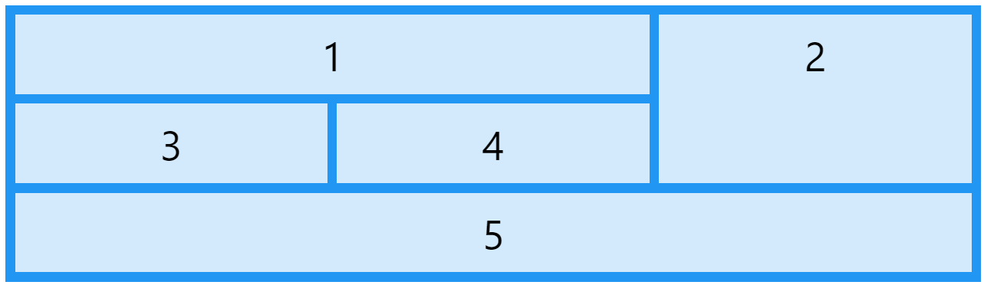

1. **Design a navigation bar using HTML and CSS.** 20
2. **Design a form using HTML and Bootstrap. (Split Inputs into 2 parts using 6 columns each**

**and add minimum 6 inputs.)** 20

